**Measures of Distribution Shape:**

* **Skewness**
* **Kurtosis**

**Skewness:**

A measure of the asymmetry of the distribution.

* Positive skewness indicates a longer tail on the right side of the distribution,
* while negative skewness indicates a longer tail on the left side.

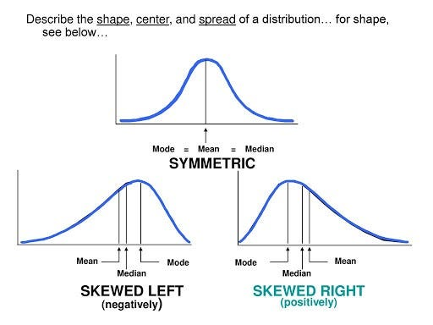

**Kurtosis:**

A measure of the peakedness or flatness of the distribution.

* Higher kurtosis indicates sharper, more peaked distributions,
* while lower kurtosis indicates flatter distributions.

